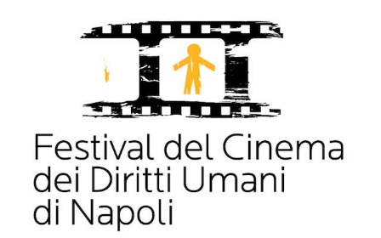

Declaration – Disclaimer – Release form

The undersigned____________________________born____________________ on _____/_______/______ and resident in_____________addres___________postal code_________________city_________________, ID or passport number________ _____________________________,

DECLARES

- to have read the Rules of the "Human Rights Film Festival of Naples" and to accept them in all its parts;
- to be the holder of all the rights and to have the legal responsibility of the work presented with regard to its contents;
- to have not infringed copyrights of third parties;
- to authorize the screening of my work completely free of charge for the screening(s) scheduled at the "Human Rights Film Festival of Naples";
- To authorize the festival organizers and interested parties exclusively for the activities of the "Human Rights Film Festival of Naples", to the processing of my personal data in accordance with the Legislative Decree No. 196 of 30 June 2003 on the protection of privacy.

DATE SIGNATURE

